Startup Funding Success Prediction and Investor Pattern Analysis
Case Study report submitted in partial fulfillment of the Requirements for the Award of the Degree of
BACHELOR OF ENGINEERING
in
ARTIFICIAL INTELLIGENCE AND DATA SCIENCE
By
Ushasree - 160124771017
Under the Mentorship of
[Mentor name]

DEPARTMENT OF ARTIFICIAL INTELLIGENCE AND DATA SCIENCE
CHAITANYA BHARATHI INSTITUTE OF TECHNOLOGY
HYDERABAD - 500075
October 2026

CHAITANYA BHARATHI INSTITUTE OF TECHNOLOGY
(AUTONOMOUS)
DEPARTMENT OF ARTIFICIAL INTELLIGENCE AND DATA SCIENCE
CERTIFICATE
This is to certify that the course case study report entitled Startup Funding Success Prediction and Investor Pattern Analysis being submitted by
Ushasree 160124771017
in partial fulfillment for the award of the Degree of Bachelor of Engineering in Artificial Intelligence and Data Science to the CHAITANYA BHARATHI INSTITUTE OF TECHNOLOGY, HYDERABAD carried out under my mentorship and supervision during the year 2026-27. The results presented in this case study report have not been submitted to any other university or Institute for the award of any degree.
[Mentor name]
[Designation]

Startup Funding Success Prediction and Investor Pattern Analysis
Indian Startup Funding Analysis and Funding-Amount Prediction Using R

1. Introduction and Problem Statement
Startups depend on external funding, and investors want to understand where capital flows: which industries, cities and funding stages attract the most money, and which investors are most active. This project analyses a public Kaggle dataset of Indian startup funding records (January 2015 to January 2020) and presents the findings through an interactive R Shiny dashboard and a Random Forest model.
Problem: Given a record of a funding event (industry, city, investment type, year), can we estimate whether the amount raised is higher or lower than the median recorded amount, and what patterns do investors and sectors show?
Important scope note: the dataset contains only funding events that took place. It has no information about startups that were rejected. The model therefore predicts the funding-amount category of a recorded deal, not whether a startup will actually succeed in getting funded.

2. Objectives
- Clean and standardise the raw Kaggle funding data using R.
- Analyse funding by year, industry, city, investment type and investor.
- Visualise the patterns with ggplot2 charts inside a Shiny dashboard.
- Train and evaluate a Random Forest classifier for the Higher / Lower funding-amount category.
- Maintain the work in an R Markdown report and under version control.

3. Dataset
Source: Kaggle "Indian Startup Funding" dataset (file startup_funding.csv). It holds 3,044 records and 10 columns covering funding events from 2 January 2015 to 13 January 2020.
Column | Description
Sr No | Serial number (not used in analysis)
Date dd/mm/yyyy | Date of the funding event
Startup Name | Name of the funded startup (some entries are web addresses)
Industry Vertical | Sector of the startup
SubVertical | More detailed business description (not used)
City Location | City of the startup
Investors Name | One or more investors, comma-separated
InvestmentnType | Funding type or stage (the column name contains a typo in the source file)
Amount in USD | Funding amount; Indian-style digit grouping (e.g. 20,00,00,000), many missing values
Remarks | Free text (not used)

The synthetic file StartupFunding_UI_Sample.csv included in the project is only for testing the dashboard interface. All results in this document use the Kaggle file.

4. Data Preparation
All cleaning is done in the prepare_data() function of app.R. Column names are first converted with janitor::make_clean_names(), then the following steps are applied.
# | Step | Detail
1 | Select and rename | Seven fields kept: startup, industry, city, investor, investment type, date, amount
2 | Remove escape junk | Literal sequences such as \xc2\xa0 and \n are removed and extra spaces squished (strip_escapes)
3 | Missing categories | Blank, NA, N/A, null and nan become "Unknown"
4 | Standardise labels | Bengaluru→Bangalore, Gurugram→Gurgaon, Delhi→New Delhi; all E-commerce spellings→eCommerce; Seed, Angel and Seed/Angel variants→Seed/Angel Funding; Private Equity Round→Private Equity
5 | Clean amounts | Commas, $, ₹ and + removed; "undisclosed", "unknown", "N/A" and similar become NA; converted to numeric
6 | Parse dates | dmy() first, then mdy() and ymd() as fallbacks; year and month extracted
7 | Remove duplicates | distinct() on the cleaned fields

Key cleaning code:
strip_escapes <- function(x) {
x <- as.character(x)
x <- gsub("\\\\+x[0-9a-fA-F]{2}", " ", x) # literal \xc2\xa0 style sequences
x <- gsub("\\\\+n", " ", x) # literal \n sequences
str_squish(x)
}
clean_amount <- function(x) {
x <- strip_escapes(x); x <- gsub(",", "", x); x <- gsub("[$₹+]", "", x)
x[tolower(trimws(x)) %in% c("", "na", "n/a", "null", "nan", "undisclosed", "unknown", "-")] <- NA
suppressWarnings(as.numeric(x))
}

Data quality summary after cleaning (as shown in the Dataset & Quality tab):
Measure | Value
Original rows | 3,044
Original columns | 10
Rows after duplicate removal | 3,044
Duplicate rows removed | 0
Missing amounts | 971 (31.9%)
Unknown industries | 171
Unknown cities | 180
Unknown investors | 24

Nearly one third of the records have no usable amount, so every amount-based table, chart and the model use only the 2,073 records with a valid positive amount. Record-count charts use all 3,044 records.

5. Data Analysis

5.1 Records by year
Year | Records | Recorded funding (USD bn)
2015 | 929 | 8.67*
2016 | 993 | 3.83*
2017 | 687 | 10.43*
2018 | 309 | 5.12*
2019 | 111 | 9.70*
2020 | 7 | 0.39*
Date missing | 8 | –
*Sum of valid amounts only. Record counts peak in 2016 and fall steadily afterwards, while the funding value is dominated by a few very large deals (for example 2017 and 2019). The 2020 figure covers only January. Year counts use strict dd/mm/yyyy parsing and exclude 8 malformed dates, so the app may differ by a few records.

5.2 Funding amount statistics
Statistic (valid amounts, n = 2,073) | USD
Total recorded funding | 38.14 billion
Mean | 18,400,340
Median | 1,750,000
25th / 75th percentile | 486,000 / 8,000,000
Minimum | 16,000
Maximum | 3,900,000,000
The mean is more than ten times the median, so the distribution is highly right-skewed. The maximum value (Rapido Bike Taxi, 3.9 billion USD) is far above all other records and may be a data-entry error in the source, so mean-based results should be read carefully.

5.3 Industry summary (top 6 by total funding)
Industry | Records | Total (USD m) | Average (USD m) | Median (USD m)
eCommerce | 205 | 8,260.7 | 40.30 | 3.00
Consumer Internet | 589 | 6,253.1 | 10.62 | 1.00
Transportation | 4 | 3,916.6 | 979.16 | 6.52
Technology | 310 | 2,229.7 | 7.19 | 1.50
Finance | 57 | 1,971.4 | 34.59 | 6.24
FinTech | 16 | 1,364.9 | 85.31 | 10.00
Transportation has only four valid records, and its average is driven by the single Rapido value, so the median is the more reliable comparison.

5.4 Investment types
Investment type | Records | Share
Seed/Angel Funding | 1,542 | 50.7%
Private Equity | 1,361 | 44.7%
Debt Funding | 25 | 0.8%
Series A | 24 | 0.8%
Series B | 20 | 0.7%
Other / Unknown | 72 | 2.4%

6. Visualization
The charts below are produced by the dashboard's ggplot2 code (the same data and logic, shown here as exported figures). The dashboard additionally lets the user filter by industry, city, investment type and year.
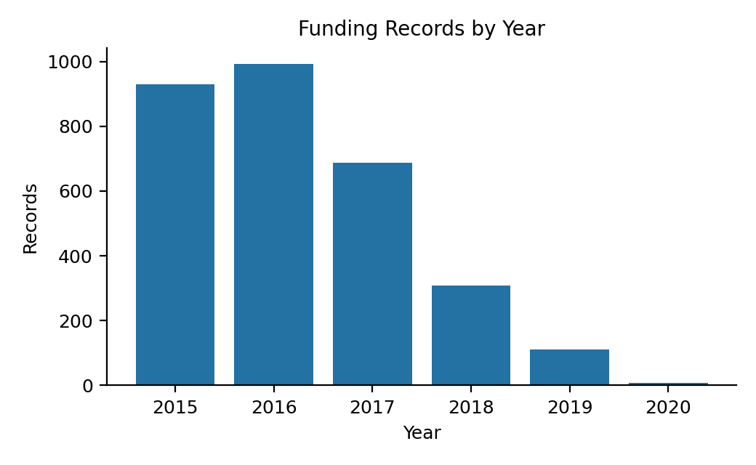  Figure 1: Records by year | 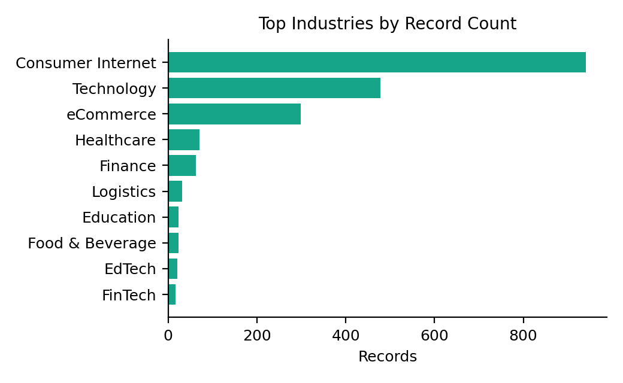  Figure 2: Top industries
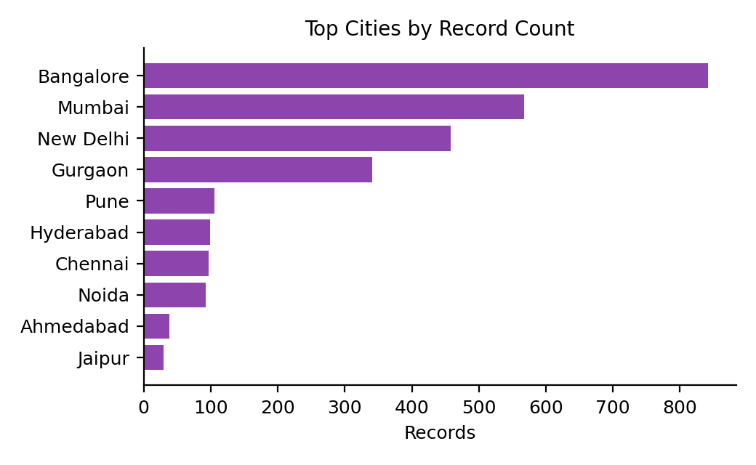  Figure 3: Top cities | 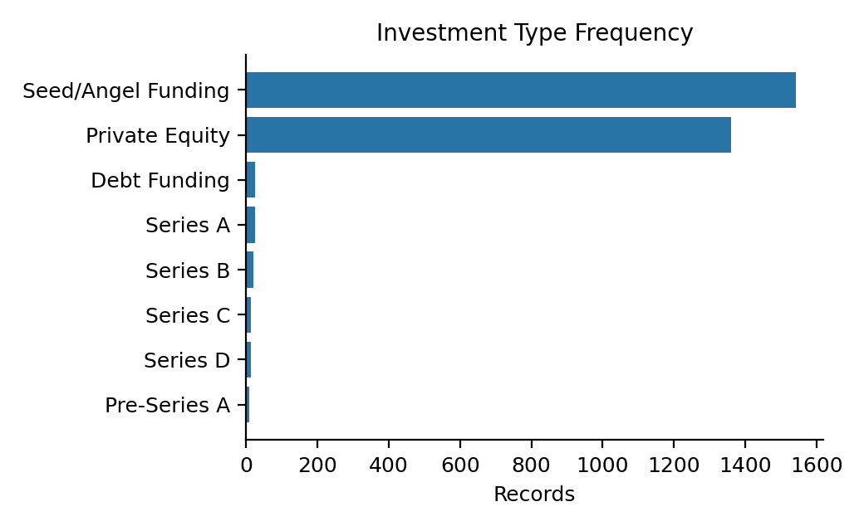  Figure 4: Investment types
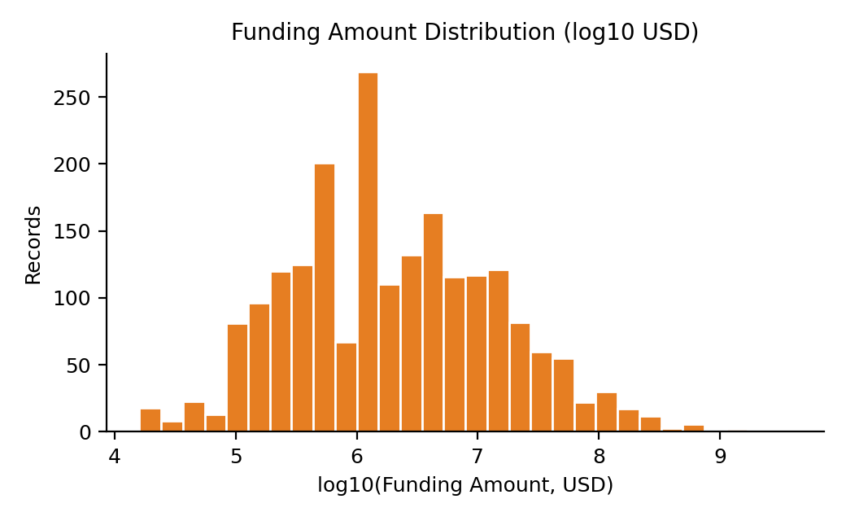  Figure 5: Amount distribution (log scale) | 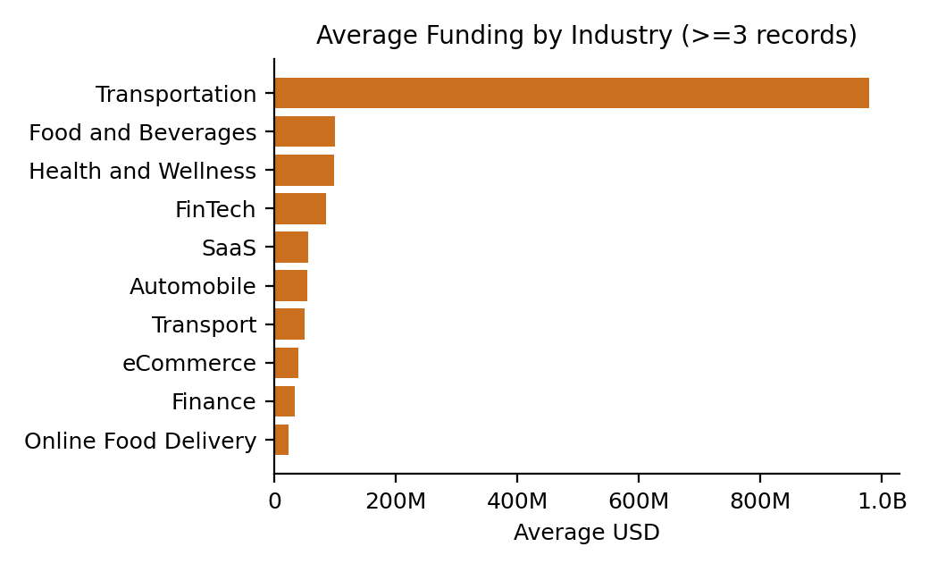  Figure 6: Average funding by industry
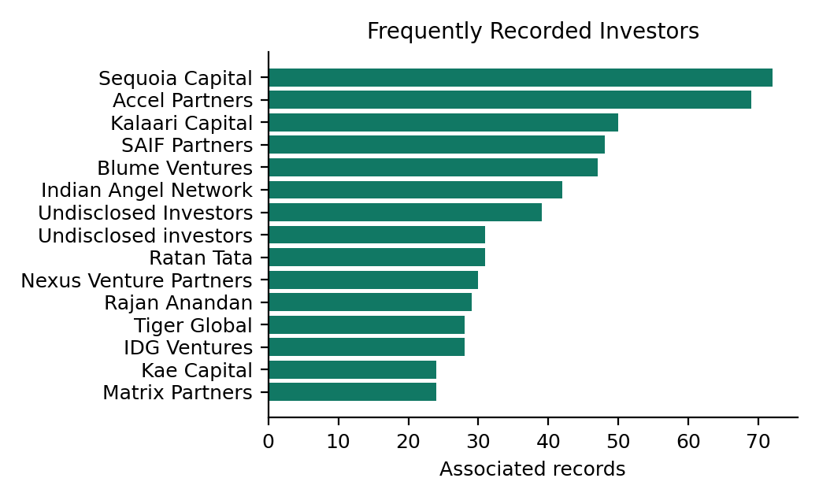  Figure 7: Most frequent investors | 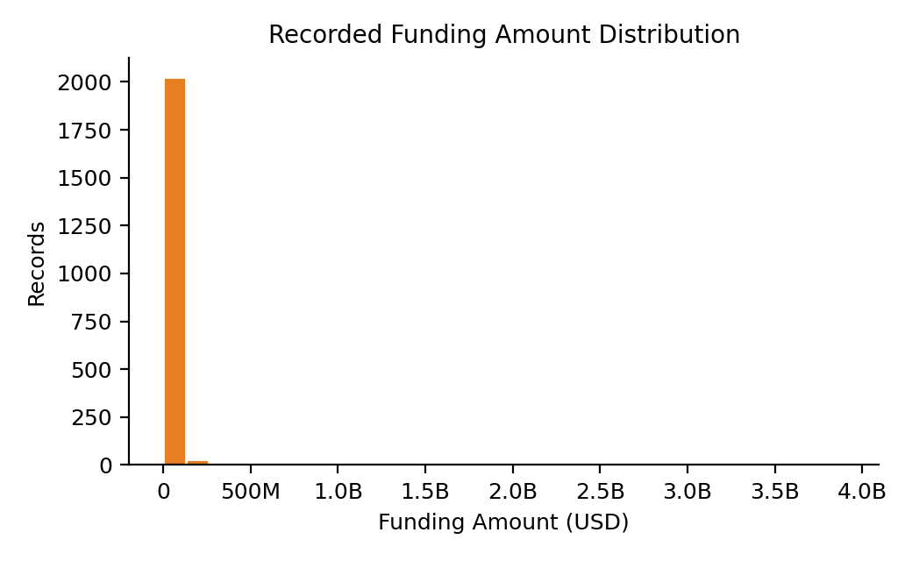  Figure 8: Amount distribution (raw scale)

Interpretation
- Activity: funding records peaked in 2016 (993) and declined each year after, down to 111 in 2019.
- Industries: Consumer Internet (941 records, 30.9%) and Technology (478, 15.7%) lead by count; eCommerce (299, 9.8%) is third but leads by total funding.
- Cities: Bangalore (842, 27.7%), Mumbai (568, 18.7%), New Delhi (458, 15.0%) and Gurgaon (341, 11.2%) account for about 73% of records.
- Investors: Sequoia Capital (72), Accel Partners (69), Kalaari Capital (50), SAIF Partners (48) and Blume Ventures (47) are the most frequently recorded. "Undisclosed Investors" also appears (70 records across two spellings) and is not a real investor.
- Amounts: the raw-scale histogram (Figure 8) is almost one tall bar because of extreme values; the log scale (Figure 5) shows that most deals fall between 0.1 and 10 million USD.

Dashboard interface (front end)
The front end is built with shiny and shinydashboard. The user uploads the Kaggle CSV in the sidebar, and four drop-down filters (industry, city, investment type, year) update every chart, table and value box at once.
Tab | Contents
Overview | Value boxes (records, recorded funding, distinct startups, investor names); charts for records by year, top industries, top cities and amount distribution; a limitation note
Funding Analysis | Investment type chart, average funding by industry (industries with at least 3 records), searchable industry summary table
Investor Patterns | Most frequent investors, investment type distribution, investor summary table (multiple investors in one record are split and counted separately)
Prediction Model | Model evaluation text, feature importance plot, and a "Try a Prediction" form (industry, city, investment type) that returns the predicted category and class probabilities
Dataset & Quality | Data quality summary, filterable records table and a button to download the filtered CSV

7. Prediction Model

7.1 Method and rationale
A Random Forest classifier (randomForest package, ntree = 300) was chosen because it handles categorical predictors, interactions and skewed data without scaling, resists over-fitting through averaging, and provides feature importance. The target compares each record with the median recorded amount, which gives two balanced classes and avoids the extreme skew of raw amounts.
Item | Setting
Target | amount_category: "Higher" if amount ≥ median, otherwise "Lower"
Features | industry, city, investment type (rare categories grouped as "Other": top 15, 12 and 10) and year
Records used | 2,071 records with valid amount and date
Median threshold | 1,790,000 USD
Train / test split | 80% / 20% random split with set.seed(123): 1,656 training and 415 test rows
Evaluation | Accuracy, precision, recall and F1 for "Higher", plus confusion matrix

model <- randomForest(amount_category ~ industry_model + city_model + type_model + year,
data = train, ntree = 300, importance = TRUE)
pred <- predict(model, test)
cm <- table(Actual = test$amount_category, Predicted = pred)

8. Results
The values below are taken from the Model Evaluation and Feature Importance boxes of the Prediction Model tab, using the Kaggle file and the final app.R.
Metric | Value
Median threshold (USD) | 1,790,000
Training rows / Test rows | 1,656 / 415
Accuracy | 0.858
Precision (Higher) | 0.780
Recall (Higher) | 0.980
F1 (Higher) | 0.869

Confusion matrix (test set, 415 records):
Actual \ Predicted | Lower | Higher
Lower | 161 | 55
Higher | 4 | 195

Feature importance (Mean Decrease in Gini):
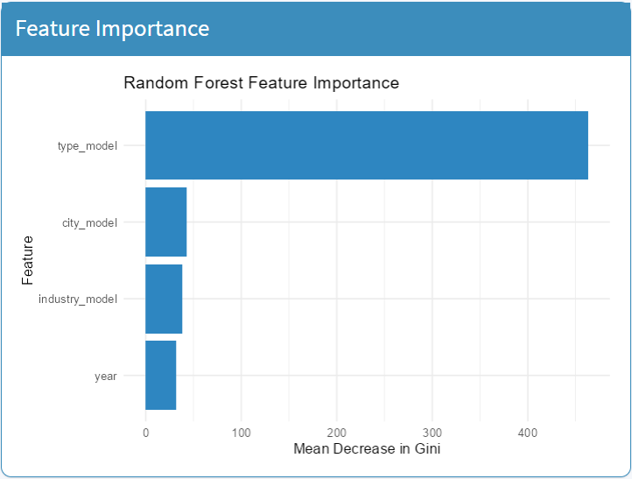
Figure 9: Random Forest feature importance (from the dashboard)

Interpretation
- Accuracy is 85.8% against a 50% baseline, because the two classes are balanced by construction. The model is clearly better than guessing.
- Recall for "Higher" is 0.98 (195 of 199 correct) but precision is 0.78, since 55 "Lower" records were wrongly predicted as "Higher". The model therefore finds almost every large deal but also over-predicts large deals. Recall for "Lower" is lower, 161 of 216 (74.5%).
- Investment type is by far the most important feature (about 470 on the Gini scale), followed by city, industry and year, each roughly 35 to 45. Funding stage and deal size are closely linked: in the cleaned data, about 81% of Private Equity records are above the median (median amount 6.0 million USD), compared with about 6% of Seed/Angel records (median 0.36 million USD).
- Because the funding stage is normally known together with the amount, the high accuracy partly reflects this built-in link. The model describes how deal types relate to deal size; it should not be read as a forecast of how much a startup will raise before a deal happens.

9. R Markdown and Version Control
The project folder contains app.R (dashboard and model), report.Rmd (short R Markdown report), README.md (setup instructions) and the sample CSV. Version control was done with named versions of app.R, saved as separate files:
Version file | What changed
app_v1_original.R | First version. The investment-type column (InvestmentnType in the Kaggle file) was not detected, so all records had type "Unknown". Median threshold 1,725,000 USD; accuracy 0.60, F1 (Higher) 0.567.
app_v2_cleaned.R | Final version. Fixed column detection, removed escape characters, merged spelling variants of city, industry and investment type, and recovered amounts with a trailing "+". Median threshold 1,790,000 USD; accuracy 0.858, F1 (Higher) 0.869.

Comparing the two versions shows how much the data cleaning mattered: fixing one column name raised accuracy from 0.60 to 0.858, with investment type becoming the most important feature.

10. Conclusion
The analysis shows that recorded startup funding in India is concentrated in a few cities (Bangalore, Mumbai, New Delhi and Gurgaon), a few sectors (Consumer Internet, Technology and eCommerce) and a small group of repeat investors led by Sequoia Capital and Accel Partners. Funding amounts are extremely skewed, with a median of 1.75 million USD against a mean of 18.4 million USD.
The Random Forest model classifies a deal as higher or lower than the median amount with 85.8% accuracy (F1 = 0.869 for the Higher class), driven mainly by the investment type. It is not a measure of whether a startup will succeed.

Limitations
- 31.9% of amounts are missing, and the amounts are the source data's own values (USD, not independently verified).
- Only funded startups appear, so there is no information about unfunded ones.
- Few features are available (no revenue, team or valuation data), which limits predictive power.
- Investor and startup names are not standardised, so some entities are counted under several spellings.

Future work
Add features such as sub-vertical and number of investors, standardise investor names, and compare with other models such as logistic regression or gradient boosting.

11. References
[1] Kaggle. Indian Startup Funding dataset (startup_funding.csv). https://www.kaggle.com
[2] Liaw, A. and Wiener, M. (2002). Classification and Regression by randomForest. R News, 2(3), 18-22.
[3] Wickham, H. et al. (2019). Welcome to the tidyverse. Journal of Open Source Software, 4(43), 1686.
[4] Chang, W. et al. shiny and shinydashboard: Web Application Framework for R. R packages. https://shiny.posit.co
[5] Firke, S. janitor: Simple Tools for Examining and Cleaning Dirty Data. R package. https://cran.r-project.org
[6] R Core Team. R: A Language and Environment for Statistical Computing. https://www.R-project.org

